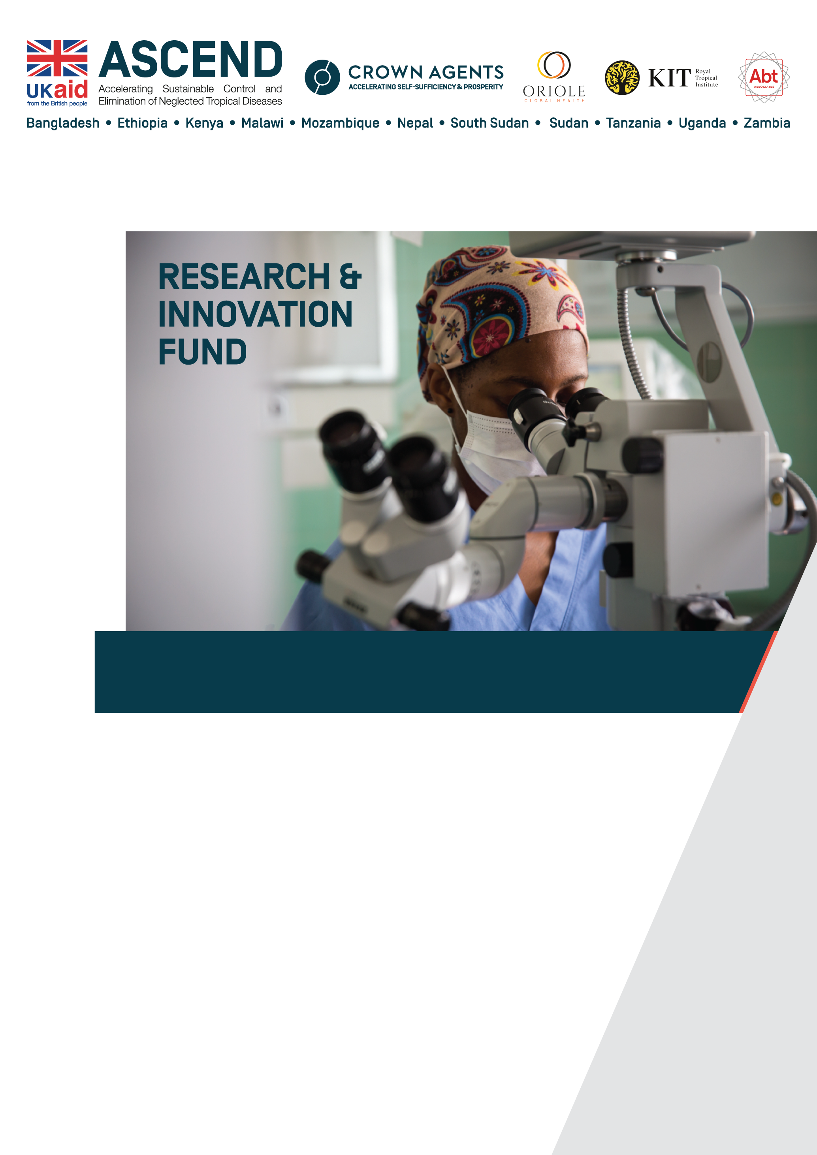
CLARIFICATIONS TO CALL FOR APPLICATIONS

Last updated: 15 January 2021

Accelerating the Sustainable Control and Elimination of Neglected Tropical Diseases (Ascend)
Southern and Eastern Africa and South Asia

Clarification Responses
Please check the date of latest update on the front cover. This document will be regularly updated as new clarification questions are received and you should check the ASCEND website regularly for updated clarifications.

No | Clarification Question | Response
1 | Can one organization submit more than one application? | Yes. As noted in Section A of the Call for Applications, Applicants may submit multiple applications.
2 | Is the Research and Innovation Fund accepting applications for soil-transmitted helminths (STH), as it is not explicitly mentioned in the call? | STH is not covered by this Ascend Lot 1 call for applications. A project which primarily addresses one of the five NTDs specified in the Call for Applications (lymphatic filariasis, onchocerciasis, schistosomiasis, visceral leishmaniasis and trachoma) but also addresses STH may be accepted. As noted in clause 14 of the Call for Applications, Applicants may contact the ASCEND team if they require initial feedback on a proposed project idea prior to preparing their application.
3 | Under the previous Research and Innovation Fund call for concepts for research proposals, we were informed that our concept was being considered and that we may be asked to prepare a full proposal at a later date. Are any concepts already submitted eligible for funding under this second round and, if so, should they be resubmitted? | Under the first call for concepts, only very few proposed studies could proceed to the full proposal stage, due to the need to prioritise limited funding. However, any concepts submitted under the previous call may still be eligible for funding under this second round, provided they meet the eligibility criteria outlined in the Call for Applications document.  If you wish to pursue an idea already submitted, you should re-submit the concept using the new application format outlined in the Call for Applications document. This is more detailed than the format previously used.  Applicants are reminded that they may contact the ASCEND team at clarifications@ascend.crownagents.com if they require initial feedback on a proposed project idea prior to preparing their application.
4 | Can one organization submit more than one application per country? | Yes. Applicants may submit multiple applications and these may be in the same country or relate to the same NTD.
5 | 1. Section 12 in the Call for Application: submission of application states that the Applicants should notify Crown Agents by email the intension to submit an applications stating the name of the applicant and subject area. On the other hand (Research and innovation fund document (Appendix A) , pg 6 section 3: Time line and process) states that the deadline for letter of intent is due on 15th Jan 2021. Please clarify the two scenarios  2. Planning Phase: We presume this to will be any time from date of advertisement of the call to 29th Jan 2021 (date for submission) and the main activities will be development of protocol and detailed budget. Please clarify if this is not correct  3. SECTION 3: TIMELINE AND PROCESS /  • Successful applicants will be notified by mid-March 2021 on the outcomes of the selection process. This will be followed by a process of negotiating and awarding contracts.  Contracted applicants will have the opportunity to fully develop their detailed proposals and plans in a short  planning phase. Approval of the planning phase will be required prior to continuing to the implementation  phase. All activities and reports of the implementation phase have to be completed and submitted by the 31st  of January 2022.  QN: Please clarify if the study period is less than 8 months, bearing in mind of logistical issues which include ethical considerations. | - The two documents are referring to the same requirement with the same deadline of 15 January. We are requesting you to notify us of your intention to submit an application by 15 January through means of an email to technicalbids@ascend.crownagents.com. This can be through a short email or through attaching a letter of intent to the email. This notification is purely for information purposes and should not be confused with the application itself, which has a deadline of 10.00 (UK time) on 29 January 2021.  - The period up to 29th January 2021 is the time for preparation of applications (it is not the planning phase). Applications should be prepared using the templates at Appendix B of the Call for Applications. Please note that the application requires only an outline of the proposed project and not a full proposal. The concept note format therefore has page limits. The planning phase will take place following the award of contracts to successful applicants; this planning phase will be used to develop detailed proposals and budgets for implementation, in accordance with the agreed contract.  - We confirm that all project activities must be completed by 31st January 2022 as FCDO funding for Ascend will not be available after this date due to the expiry of Crown Agents’ contract with FCDO. We appreciate that this is a short time period for many potential studies and recommend that applicants ensure that their proposed project is feasible within the time period available.
6 | Could you clarify what costs are NOT eligible, and what the maximum allowed indirect rate and/or NPAC is? The FCDO budget guidance link provided at the bottom of page 6 of the Call for Applications file does not seem to work. | Please try the following link which we have checked:  https://assets.publishing.service.gov.uk/government/uploads/system/uploads/attachment_data/file/888316/Eligible-Cost-Policy-28May2020.pdf  It is not possible to give an exhaustive list of ineligible costs, but Annex C of the Ascend subcontract (found in Appendix C1 of the Call for Applications) gives further guidance.  There is no fixed maximum indirect rate or NPAC as NPAC are not necessarily proportional to the direct costs of a project. You are required to calculate NPAC in accordance with the FCDO budget guidance referenced.
7 | Can you clarify the position on Full Economic Costing for UK institutions?  Can you clarify whether indirect costs are allowed under to proposal, or if it is only direct costs. Is there a percentage for indirect costs, as this does not appear in the outline budget. Is the percentage the same for lead and coapplicants? Is the percentage the same for UK institutions and those from Eastern and Southern Africa? | The same budget guidance applies to all applicants, regardless of nationality.Please see the FCDO Eligible Cost Policy at the link below. This explains which costs are permitted and covers both direct programme costs and non-project attributable costs (NPAC) which are also known as indirect costs.  https://assets.publishing.service.gov.uk/government/uploads/system/uploads/attachment_data/file/888316/Eligible-Cost-Policy-28May2020.pdf  There is no fixed maximum percentage for indirect costs or NPAC as these are not necessarily proportional to the direct costs of a project. You are required to calculate NPAC in accordance with the FCDO budget guidance referenced above. This guidance applies to both the lead and coapplicants and to applicants from all countries.
8 | What is the role of the ASCEND Country Lead and Regional Manager mentioned in section 5.4 Collaborators of App B Form 1? | Appendix A of the Call for Applications document explains that “We strongly encourage you to closely review the relevant Ascend activities and coordinate with Ministries of Health as well as Ascend Country Leads and partners before applications are submitted. This will avoid duplication and ensure complementarity to ongoing activities.”  The Ascend Country Lead and Regional Manager don’t necessarily have a specific role. Under section 5.4, please explain what consultations have taken place with the Country Lead, Regional Managers and/or Ministries of Health and the outcome of these consultations.
9 | We've tried on a few different computers, however, whenever we click the FCDO budget guidance file that you've provided in the Call for Applications (https://assets.publishing.service.gov.uk/government/uploads/system/uploads/attachment_data/file/866690/Eligible-Cost-Policy.pdf), the link states the following: {"_response_info":{"status":"not found"}}. Could you please include the pdf in the Procurement Notice.  What are the eligible costs for overhead/coordination? | We have now loaded the FCDO budget guidance file onto the website page with the Call for Applications. If any applicant is still unable to access it here, please contact us at clarifications@ascend.crownagents.com and we will email it directly to you.  This guidance document explains which costs are eligible for overheads and coordination.
10 | Whereas Ascend West welcomes proposals that include activities to tackle other NTDs included in the London Declaration on NTDs (beyond the listed NTDs), the Ascend East funding guidelines do not provide that information. May we include other NTDs in addition to the listed NTDs? | A project which primarily addresses one of the five NTDs specified in the Call for Applications (lymphatic filariasis, onchocerciasis, schistosomiasis, visceral leishmaniasis and trachoma) but also addresses other NTDs may be accepted. As noted in clause 14 of the Call for Applications, Applicants may contact the ASCEND team if they require initial feedback on a proposed project idea prior to preparing their application.
11 | Regarding the budget template for the Research and Innovation Fund, could you provide a clarification what “Function” means? Is this asking for a general description/purpose of the budget line? | Yes, this should be a brief explanation of the purpose of the proposed item of expenditure.
12 | As projects need to end 31 January 2022 and as there needs to be a planning phase, how much time will be available for doing the research? If we obtain ethical approval for the research proposal before the start of the project could we then include preparatory field visits in the planning phase and start with the research very early thereafter? | Applicants are expected to propose the activities and timings of the planning and implementation phases, according to the needs of the project and taking into account ethical review processes, where relevant. All project activities must be completed by 31st January 2022 but there is no fixed date for the completion of the planning phase.  Preparatory field visits may be included in the planning phase where they are required to fully develop detailed proposals and plans for the implementation phase.
13 | Does the time table and references count for the number of pages or can they be added as annex? | Workplans and references may be annexed to the application and are not included in the suggested 10 page maximum.

Any further clarification questions should be sent to clarifications@ascend.crownagents.com.

