DESIGN SPECIFICATION
FOR
ELECTRICAL UPGRADES AND RETROFITS FOR 40 PRIMARY HEALTHCARE CENTRES (PHCs) IN KADUNA STATE

Contents

1. Project Background 3
2. The Employer 3
3. General Requirements 3
3.1 Conditions of Contract 3
3.2 Intended Purpose of the Systems 3
3.3 Locations of the Sites and Sectioning the Works 3
4. Scope of Works 3
4.1 PHC Electrical Upgrades and Retrofits 4
5. Design and Construction Standards 5
6. As-Built Documents 5
7. Tests on Completion 5
8. Time for Completion and Programme of Works 6
Appendix A: List of Sites and Site Survey Report 7
A.1 List of Sites 7
A.2 Site Survey Report 9
Appendix B: Solar System Design Loads 10
Appendix C: Technical Specification and Compliance Statement 13
Appendix D: [Intentionally left blank] 14
Appendix E: [Intentionally left blank] 15
Appendix F: Electrical Retrofits and Upgrades Designs 16
F.1 Electrical Retrofit Design 16
F.2 Requirements for Electrical Installations 16
F.3 Electrical Retrofit Drawings for 40 PHCs (KCS/EM/RD/DRW) 16
F.4 Electrical Retrofit Bill of Materials 16
Appendix G: Commissioning and Performance Tests 17
G.1 Commissioning Tests and Processes 17
G.2 [Intentionally Left Blank] 17

Project Background
The DFID ‘Kaduna Clinics’ project (“the Project”) will provide solar power for 40 Primary Healthcare Centres (PHCs, “the Sites”) across Kaduna State. The Project comprises the design, procurement, construction, installation, commissioning and training for 40 stand-alone, off-grid, photovoltaic (PV) solar generating systems (“the System”). Additionally, the Project will include electrical upgrades to all PHCs as required to receive and utilise power generated by the Systems. The Systems will comprise PV solar arrays, integrated battery banks, inverters, charge controllers, distribution equipment, remote monitoring systems, PV array mounting structures and enclosures to house the battery banks and System electronics. The Systems will be designed to provide total power to the PHCs, 24 hours a day.
The Scope of Works defined in this Design Specification (“the Specification”) covers electrical upgrades and retrofits for the PHCs. This Specification includes as Appendices, the required drawings, bills of materials and diagrams for the execution of the Works.

The Employer
The Electrical Contractor will be contracted by Crown Agents Limited (“the Employer”) who are acting as a procurement agent for the Department for International Development, Government of the United Kingdom (DfID) for the execution of these Works. The Beneficiary of the Works will be the SolarNigeria Programme ( “the Beneficiary”).
The Employer will assign a Project Management Unit (PMU) to administer the execution of the Contract. The PMU shall oversee the execution of this Contract and shall act on behalf of the Employer.

General Requirements

Conditions of Contract
The Retrofit and Upgrade works will be governed by the Crown Agents Conditions of Contract for the Procurement of Goods and Associated Services (“the Goods Contract”).

Intended Purpose of the Systems
The Systems will provide reliable supplies of electricity to the 40 PHCs to meet the total power requirements of the PHCs, 24 hours a day, 365 days a year. Electrical retrofits and upgrades to all 40 PHCs will ensure that the PHCs can utilise the generated power effectively, efficiently and safely.

Locations of the Sites and Sectioning the Works
Reference and Design Documents:
Appendix A List of Sites and Site Survey Report
The Electrical Contractor shall familiarise themselves with the locations of Sites given in Appendix A.1. The Electrical Contractor shall divide the Works into three Lots, or groups of Sites which will be completed and Taken Over as units. The Lots are defined in Table 2, Appendix A.1 (below).

Scope of Works
The Scope of Works is based on the detailed designs completed by the Employer as defined in this Specification and its appendices. Table 2 shows a high-level breakdown of the Scope of Works for which the Electrical Contractor will be responsible. The table also highlights areas of responsibility of the other Contractors, the Kaduna State Government (KSG) and for the Project Management Unit (PMU).
Table 1 Scope of Works: High-Level Breakdown by Work Package
No. | Description | KSG | Civil Contractor | Electrical Contractor | Solar Contractor | PMU
1 | Resolve Site Access Issues at Selected Sites | •
2 | Construct Boundary Walls at Selected Sites | •
3 | Address Overhead Powerline Issues at Selected Sites | •
4 | Address Space Issues at Selected Sites | •
5 | Security at Sites | •
6 | Site Surveys - Geotechnical |  | •
7 | Site Surveys - Earthing Test |  | •
8 | Site Surveys - Electrical |  |  | •
9 | Review and Finalise Foundation Designs |  | •
10 | Clear and Prepare Sites for foundations and landscaping |  | •
11 | Construct Foundations |  | •
12 | Landscape site, including interlocking brickwork around foundations |  | •
13 | Foundations and Landscapting - Issue of Taking-Over Certificats |  |  |  |  | •
14 | Review of Retrofit and Upgrade Designs |  |  | •
15 | Procure Materials for Retrofits and Upgrades |  |  | •
16 | Install Retrofits and Upgrades |  |  | •
17 | Electrical Tests on Completion 1 (Pre-Commissioning) |  |  | •
18 | Electrical Tests on Completion 2 (Commissioning) |  |  | • |  | •
19 | Electrical Tests on Completion 3(Performance Testing) |  |  | • |  | •
20 | Retroftis and Upgrades - Issue of Taking-Over Certificates |  |  |  |  | •
21 | Review Solar System, Enclosures and Mounting Structure Designs |  |  |  | •
22 | Procure and Modify Enclosures |  |  |  | •
23 | Mount Enclosures on Foundations at Sites |  |  |  | •
24 | Procure PV Panel Support Structures |  |  |  | •
25 | Install PV Panel Support Structures on Foundations at Sites |  |  |  | •
26 | Procure PV Components and Materials |  |  |  | •
27 | Conduct Quality Assurance on Selected PV Components |  |  |  | •
28 | Install PV Systems at Sites |  |  |  | •
29 | Integrate PV Systems with PHCs |  |  |  | •
30 | Solar Tests on Completion 1 (Pre-Commissioning) |  |  |  | •
31 | Solar Tests on Completion 2 (Commissioning) |  |  |  | • | •
32 | Solar Tests on Completion 3 (Performance Testing) |  |  |  | • | •
33 | Solar Generators - Issue of Taking-Over Certificates |  |  |  |  | •
34 | Prepare Project-Specific O&M Plan | • |  |  |  | •
35 | O&M Team Building | • |  |  |  | •
36 | O&M Trainging - Workshops and Field Training | • |  |  | • | •
37 | Monitoring System Performance | •

PHC Electrical Upgrades and Retrofits
Reference and Design Documents:
Appendix C Technical Specification and Compliance Statement
Appendix F Electrical Retrofits and Upgrades Designs
The Electrical Contractor shall be responsible for completing the required upgrades and retrofits of the electrical wiring, power outlets and permanent fixtures for all PHCs. The Upgrades and Retrofits are necessary to facilitate the effective, safe and efficient utilisation and management of electrical power which will be generated by the PV Systems or supplied by the grid (where connections exist). For most PHCs, existing wiring has been poorly maintained and is inadequate to serve the needs of the PHCS. Several PHCs have not been wired at all and will require new wiring systems.
The Upgrade and Retrofit Designs (Appendix F) include complete wiring layouts and Bills of Materials (BOMs) for all 40 Sites. The objectives of these designs are:
- To ensure the PV System is connected to a reliable wired network in the PHC.
- Replacement of all low-efficiency energy installations with energy efficient fittings.
- Provide solar power to critical load only and connect grid power to all non-critical loads.
- Replace all obsolete, broken or faulty fittings with new fittings.
- Provide adequate lighting, cooling fans and sockets to the PHCs and discourage tampering with installations.
- Redistribution of PHC loads and establishment of proper MCB ratings for robust operation and protection.
The technical specifications and compliance statement (Specification 06021031, Appendix C) appended to this specification shall serve as a guide to the Contractor for the procurement of components listed in the Bill of Materials (Appendix F.4).

Design and Construction Standards
The standards and codes with which the components, structures and installations must comply are listed in Appendix F.2.

As-Built Documents
Prior to commencing the Tests on Completion (described in section 7, below) the Contractor shall prepare a complete set of As-Built Documents and submit these to the Engineer for review and approval. The As-Built Documents shall include the following:
- Single-Line Diagrams (SLDs) of the Retrofits and Upgrades to 40 PHCs
- BOMs for the Retrofits and Upgrades highlighting and quantifying any deviations from the Specification for 40 PHCs

Tests on Completion
For the Electrical Works and Solar Installations, Tests on Completion will include the following:
- Pre-Commissioning System Inspections (Appendix G.1)
- Commissioning Checks and Tests (Appendix G.1)
The Solar Contractor shall satisfactorily conclude the Tests on Completion within the Time for Completion.

Time for Completion and Programme of Works
The Time for Completion for the Works described in this Specification shall be determined in relation to the following critical project milestones:
- Completion of all Sites: no later than 30th April 2015
The Electrical Contractor shall prepare detailed Schedules demonstrating compliance with the critical milestones listed above. The Schedules shall make references to detailed Risk Registers including:
- Clear identification, qualification and quantification of specific risks to successful completion on time;
- Mitigating measures for each risk;
- A clear, workable plan to monitor and update the risk register on a monthly basis.
The Schedules shall be submitted with the Electrical Contractor’ bids and the Electrical Contractor shall submit to the Engineer for approval the risk registers and risk monitoring plans within 20 days of the Commencement Date.

Appendix A: List of Sites and Site Survey Report

A.1 List of Sites
Figure 1 (below) shows the locations of the PHC Sites. The GPS locations for the Sites are shown in Table 2.
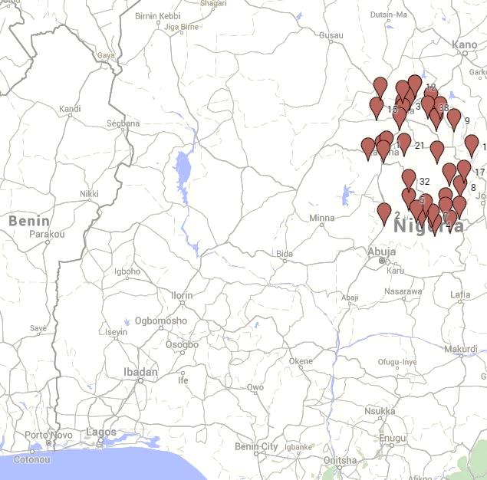
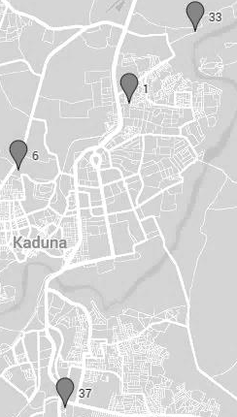
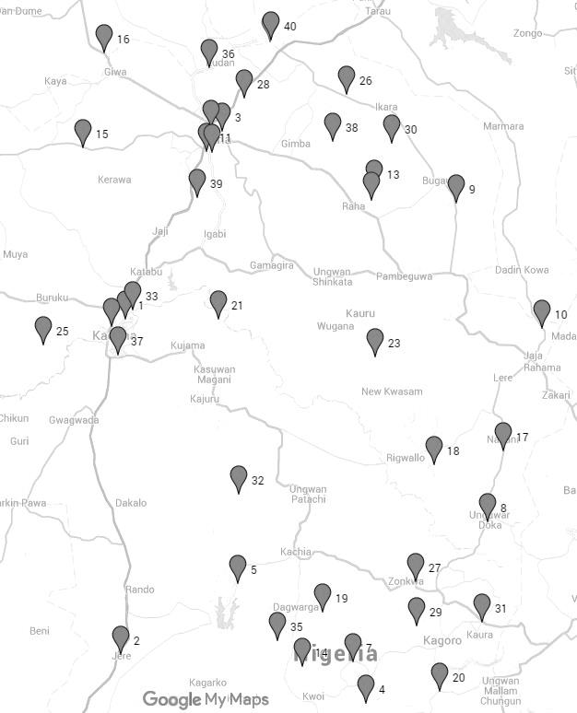
12
40
24
11
34
22
Figure 2 PHC Locations in Kaduna State, Nigeria
The following Table shows the GPS co-ordinates and PHC names corresponding to the numbered locations shown in the map in Figure 1. The Sites are grouped into three Lots.
Table 2 GPS Co-ordinates of the PHC Sites
S/No. | Site Name | Latitude | Longitude | Lot
1 | BADARAWA PHC | 10.559183 | 7.447883 | Kaduna Central
6 | PHC BADIKO | 10.535867 | 7.4084 | Kaduna Central
10 | PHC DAN ALHAJI | 10.531483 | 8.6898 | Kaduna Central
21 | PHC GWARAJI | 10.556767 | 7.726267 | Kaduna Central
23 | PHC KADAGE | 10.4478 | 8.193417 | Kaduna Central
25 | PHC DAMBA KASAYA | 10.483033 | 7.20565 | Kaduna Central
33 | PHC RAFIN GUZA | 10.583983 | 7.471483 | Kaduna Central
37 | PHC TELEVISION GARAGE | 10.453083 | 7.425467 | Kaduna Central
3 | PHC ABDU KWARI | 11.108133 | 7.738233 | Kaduna North
9 | PHC DAMAU | 10.897833 | 8.433867 | Kaduna North
11 | PHC DAN JINJIRI | 11.048583 | 7.691783 | Kaduna North
12 | PHC DAN GUZURI | 11.368483 | 7.8802 | Kaduna North
13 | PHC DANWATA | 10.941433 | 8.190083 | Kaduna North
15 | PHC Galadimawa | 11.05975 | 7.322733 | Kaduna North
16 | PHC GANGARA | 11.33785 | 7.384583 | Kaduna North
22 | PHC HANWA | 11.116767 | 7.703617 | Kaduna North
24 | PHC KAMARU IKULU | 10.905467 | 8.181817 | Kaduna North
26 | PHC KURMIN KOGI | 11.215167 | 8.107567 | Kaduna North
28 | PHC LIKORO | 11.204217 | 7.80265 | Kaduna North
30 | PHC MAH | 11.073383 | 8.242733 | Kaduna North
34 | PHC RIMIN DOKO KAURA | 11.0461 | 7.708217 | Kaduna North
36 | PHC TASHAN KADE (DANDAKO) | 11.293533 | 7.69905 | Kaduna North
38 | PHC TURAWA | 11.07835 | 8.067317 | Kaduna North
39 | PHC ZANGO AYA | 10.915067 | 7.66195 | Kaduna North
40 | PHC MAKARFI (TUDUN WADA) | 11.374767 | 7.881483 | Kaduna North
2 | JERE PHC | 9.573567 | 7.435317 | Kaduna South
4 | PHC ASSO | 9.429617 | 8.1651 | Kaduna South
5 | PHC AWON | 9.780917 | 7.784717 | Kaduna South
7 | PHC DADDU | 9.552167 | 8.128433 | Kaduna South
8 | PHC DAMA KASUWA | 9.962933 | 8.52865 | Kaduna South
14 | PHC FAI | 9.537617 | 7.974717 | Kaduna South
17 | PHC GARU KURAMA | 10.171667 | 8.576017 | Kaduna South
18 | PHC GESHERE | 10.1322 | 8.369033 | Kaduna South
19 | PHC GIDAN TAGWAI | 9.698483 | 8.035133 | Kaduna South
20 | PHC GIDAN WAYA | 9.466533 | 8.38415 | Kaduna South
27 | PHC KURMIN BI | 9.787583 | 8.312967 | Kaduna South
29 | PHC MADAKIYA | 9.65755 | 8.316067 | Kaduna South
31 | PHC MANCHOCK | 9.6688 | 8.512167 | Kaduna South
32 | PHC MARO | 10.044967 | 7.78545 | Kaduna South
35 | PHC RUZIA | 9.615017 | 7.902883 | Kaduna South

A.2 Site Survey Report

Appendix B: Solar System Design Loads
B.1 Standard System Sizes Summary Table

B.1 Standard System Sizes
S/N | PHC CLINCS | LOCAL GOVERNMENT | PEAK LOAD W | Critical load +30% of critical load W | ENERGY REQUIRED DAILY | HOURS OF DAILY GRID SUPPLY | SYSTEM SIZE | PV SIZE KWp
 |  |  | a | b = a x 1.3 | c = b x 18(hours)
1 | BADARAWA PHC | Kaduna North | 14,386.00 | 18,701.80 | 336,632 | 12 | 7 | 112.32
2 | JERE PHC | Kagarko | 2,908.00 | 3,780.40 | 68,047 | 8 | 5 | 28.00
3 | PHC ABDU KWARI | Sabon Gari | 2,490.00 | 3,237.00 | 58,266 | 2 | 3 | 28.08
4 | PHC ASSO | Jemaa | 140.00 | 182.00 | 3,276 | 12 | 1 | 14.04
5 | PHC AWON | Kachia | 8,053.00 | 10,468.90 | 188,440 |  | 6 | 84.24
6 | PHC BADIKO | Kaduna South | 3,245.00 | 4,218.50 | 75,933 | 11 | 5 | 28.00
7 | PHC DADDU | Jaba | 5,280.00 | 6,864.00 | 123,552 | 4 | 4 | 56.16
8 | PHC DAMA KASUWA | Kauru | 6,638.00 | 8,629.40 | 155,329 | 3 | 6 | 84.24
9 | PHC DAMAU | Kubau | 2,436.00 | 3,166.80 | 57,002 |  | 3 | 28.08
10 | PHC DAN ALHAJI | Lere | 6,707.00 | 8,719.10 | 156,944 | 4 | 6 | 84.24
11 | PHC DAN JINJIRI | Zaria | 1,093.00 | 1,420.90 | 25,576 |  | 1 | 14.04
12 | PHC DANGUZURI | Makarfi | 3,786.00 | 4,921.80 | 88,592 | 1 | 3 | 28.08
13 | PHC DANWATA | Soba | 870.00 | 1,131.00 | 20,358 |  | 1 | 14.04
14 | PHC FAI | Jaba | 1,077.00 | 1,400.10 | 25,202 |  | 1 | 14.04
15 | PHC Galadimawa | Giwa | 5,367.00 | 6,977.10 | 125,588 |  | 4 | 56.16
16 | PHC GANGARA | Giwa | 8,632.00 | 11,221.60 | 201,989 | 4 | 6 | 84.24
17 | PHC GARU KURAMA | Lere | 5,931.00 | 7,710.30 | 138,785 |  | 4 | 56.16
18 | PHC GESHERE | Kaura | 3,446.00 | 4,479.80 | 80,636 |  | 4 | 56.16
19 | PHC GIDAN TAGWAI | Kachia | 2,415.00 | 3,139.50 | 56,511 |  | 3 | 28.08
20 | PHC GIDAN WAYA | Jemaa | 7,633.00 | 9,922.90 | 178,612 | 12 | 6 | 84.24
21 | PHC GWARAJI | Igabi | 2,322.00 | 3,018.60 | 54,335 |  | 3 | 28.08
22 | PHC HANWA | Sabon Gari | 1,730.00 | 2,249.00 | 40,482 | 6 | 2 | 21.06
23 | PHC KADAGE | Kauru | 2,370.00 | 3,081.00 | 55,458 |  | 3 | 28.08
24 | PHC KAMURU (IKUKLU) | Zangon Kataf | 6,729.00 | 8,747.70 | 157,459 | 4 | 6 | 84.24
25 | PHC KASAYA | Chikun | 2,031.00 | 2,640.30 | 47,525 |  | 2 | 21.06
26 | PHC KURMIN KOGI | Ikara | 1,660.00 | 2,158.00 | 38,844 |  | 2 | 21.06
27 | PHC KURMIN-BI | Zangon Kataf | 1,533.00 | 1,992.90 | 35,872 |  | 2 | 21.06
28 | PHC LIKORO | Kudan | 5,684.00 | 7,389.20 | 133,006 |  | 4 | 56.16
29 | PHC MADAKIYA | Zangon Kataf | 1,149.00 | 1,493.70 | 26,887 |  | 1 | 14.04
30 | PHC MAH | Kubau | 375.00 | 487.50 | 8,775 |  | 1 | 14.04
31 | PHC MANCHOCK | Kaura | 5,030.00 | 6,539.00 | 117,702 | 2 | 4 | 56.16
32 | PHC MARO | Kajuru | 1,938.00 | 2,519.40 | 45,349 |  | 2 | 21.06
33 | PHC RAFIN GUZA | Kaduna North | 3,833.00 | 4,982.90 | 89,692 | 17 | 5 | 28.00
34 | PHC RIMIN DOKO KAURA WARD | Zaria | 2,355.00 | 3,061.50 | 55,107 | 2 | 3 | 28.08
35 | PHC RUZIA | Kagarko | 1,650.00 | 2,145.00 | 38,610 |  | 2 | 21.06
36 | PHC TASHAN KADE (dandako) | Kudan | 1,726.00 | 2,243.80 | 40,388 |  | 2 | 21.06
37 | PHC TELEVISION GARAGE | Kaduna South | 6,290.00 | 8,177.00 | 147,186 | 6 | 6 | 84.24
38 | PHC TURAWA | Soba | 684.00 | 889.20 | 16,006 |  | 1 | 14.04
39 | PHC ZANGO AYA | Igabi | 7,168.00 | 9,318.40 | 167,731 | 18 | 6 | 84.24
40 | PHC MAKARFI (HC Tudun Wada) | Makarfi | 8,474.00 | 11,016.20 | 198,292 | 4 | 6 | 84.24
 |  |  |  |  |  |  | 40 | 1,733.70

Appendix C: Technical Specification and Compliance Statement
Specification No | Item
06021031 | Solar Upgrade and Retrofit Materials

Appendix D: [Intentionally left blank]

Appendix E: [Intentionally left blank]

Appendix F: Electrical Retrofits and Upgrades Designs

F.1 Electrical Retrofit Design

F.2 Requirements for Electrical Installations

F.3 Electrical Retrofit Drawings for 40 PHCs (KCS/EM/RD/DRW)

F.4 Electrical Retrofit Bill of Materials

Appendix G: Commissioning and Performance Tests

G.1 Commissioning Tests and Processes

G.2 [Intentionally Left Blank]

