An assessment of the price of oncology drugs in Ukraine 2015

Prashant Yadav
University of Michigan
October 2016

The views and opinions expressed in this report are those of the author and should not be attributed to the research institutes or departments.

Crown Agents is an internationally renowned supply chain and public procurement services provider. Over the course of 2016, Crown Agents provided procurement services as per agreement with the Ministry of Health of Ukraine for its adult and child oncology programmes funded by the 2015 Ukrainian state budget. Crown Agents were responsible for tendering, procurement and supply of 314 line items requested by MOH Ukraine, with the contract ending in December 2016. The total contract value for all programmes covered amounted to USD 31,936,612. Throughout the course of the contract, Crown Agents cooperated with international and local producers and distributors of medicines, reagents and medical devices.

Crown Agents is always exceptionally diligent and committed to fulfilling its contractual obligations to Ukraine. Thus, in order to gain an unbiased evaluation of its performance under the contract, the Company has recently ordered an independent audit research study from a renowned researcher Mr. Prashant Yadav.

Mr. Prashant Yadav

Mr. Prashant Yadav is the Director of Healthcare Research at the William Davidson Institute (WDI) at the University of Michigan and Visiting Scholar in Harvard Medical School. He holds faculty appointments at the Ross School of Business and the School of Public Health at the University of Michigan. He is also a Visiting Scholar at INSEAD Social Innovation Center. Prashant Yadav is a globally recognized researcher, educator and policy advisor in the area of healthcare supply chains.

He serves as an advisory board member of several public-private partnerships focused on healthcare delivery in low-income markets and advisor to many large private foundations, multilateral agencies and country governments.

He is the author of many peers-reviewed scientific publications and his work has been featured in prominent print and broadcast media including The Economist, The Financial Times, Nature and BBC.
Prior to coming to the William Davidson Institute at the University of Michigan, Dr. Yadav was a Professor of Supply Chain Management at the MIT-Zaragoza International Logistics Program and a Research Affiliate at the MIT Center for Transportation and Logistics where he led the creation of a high impact research initiative focused on pharmaceutical supply chains in developing countries.

Yadav received his undergraduate training in Chemical Engineering, his MBA in Operations and Finance and his PhD in Management Science. Before academia, he has worked in pharmaceutical strategy, management consulting and supply chain technology companies.

www.pharmaceutical-supplychain.org
www.linkedin.com/in/prashantyadavsupplychain

Acknowledgements
The author gratefully acknowledge key contributions of the individuals listed below who provided information and insights for the study. Any errors, inaccuracies, or omissions are, however, entirely the responsibility of the authors.
Thomas Brown, Crown Agents
Olga Silvestrova, Crown Agents
Christine Jackson, Crown Agents
This study was funded by Crown Agents UK.

Table of Contents

Executive Summary | 5
Background, objectives and methodology | 6-8
Study limitations | 8
Results | 9-13
Conclusions and Future Outlook | 14
References | 15
Appendix A: List of drugs | 16-22
Appendix B : Currency Conversion Averages | 23

Executive Summary

Cancer medicines are one of the biggest drivers of healthcare budgets globally, and contribute substantially to overall pharmaceutical costs. Pricing for these medicines is a complex process, but there are some simple methods to help lower prices, such as improving procurement processes and better negotiations with suppliers/manufacturers.

In 2015, the government of Ukraine outsourced the procurement of all adult and pediatric oncology medicines to Crown Agents. This report evaluates the impact of this initiative on 2015 drug prices, as compared to prices from the prior year. While price reductions for pharmaceuticals can occur as a result of changes in market conditions, volume, quality of suppliers, and other factors, this study seeks to disentangle these effects so as to understand if 2015 prices were lower than those in 2014 due to improved procurement efforts. Lack of data availability on changes in supply competition, input prices and supplier quality required making multiple simplifying assumptions.

The procurement of oncology drugs in Ukraine achieved significant price reductions in 2015. The net price to the Ministry of Health of Ukraine decreased by an average of 37.9%. Approximately 84% of the 168 items procured had a lower net price in 2015 as compared to 2014. A large portion of these price reductions was due to greater procurement efficiency and transparency. External factors such as changes in volume, market conditions, and supplier quality contributed only marginally to these price reductions.

Prices obtained by Ukraine were better or comparable to most global procurers of high quality oncology medicines. Additionally, price reductions were achieved without compromising the quality of manufacturers. In the few instances where prices in 2015 were higher as compared to 2014, it was on account of too few suppliers registered in Ukraine to supply that product.

Ukraine presents a sizeable opportunity for suppliers and distributors, particularly those with significant oncology portfolios. Sharing information about the size of the Ukraine market could incentivize more suppliers register in the country and help further reduce the procurement spend.

Over the next several years, there will be an influx of oncology medicines due to an increasing cancer disease burden combined with advances in diagnoses and early treatment options. The market landscape is therefore likely to become increasingly complex. In such an environment, it will be imperative to ensure that procurement is managed by organizations that not only understand these complexities, but have the ability to find efficiencies within the system without sacrificing quality.

Background

Pharmaceutical pricing is an increasingly complex process that can be a major challenge for healthcare policy makers worldwide. There are a number of factors that can serve as key drivers for high prices, including weak public procurement systems. However, strategies such as more efficient procurement, skillful negotiation, and increased competition can help to achieve lower prices.

In 2015, the Ministry of Health of Ukraine decided to outsource the procurement of its HIV/AIDS medicines, oncology drugs, and several other products to global procurement agents. Crown Agents was selected to procure adult and child oncology medicines. While the company was responsible for managing and delivering all specified medicines, it was not responsible for choosing the types and quantities of the medicines to be procured.

Now that the first year of the project is complete and the majority of medicines have been procured and delivered, it is crucial to assess the impact of the procurement program and to rigorously examine whether prices paid by Ukraine were “efficient.”.

Objectives of this study

Crown Agents commissioned this independent study so as to obtain a deeper and more structured understanding of what this project has achieved, and to identify potential areas for improvement.

The underlying goals of this study are to:

  - Analyze the 2015 prices paid for oncology medicines in Ukraine (in comparison to 2014 prices) in an effort to disentangle the effects of market changes, currency fluctuations, volume changes, input cost changes, and procurement efficiencies.

  - Compare the prices paid in 2015 to prices paid by other relevant countries and large procurers.

Data and Methodology

There were 168 products in Ukraine’s list of drugs for child and adult cancers. These included different strengths and formulations resulting in a total of 93 drugs. While there are some nuances to the list of drugs in Ukraine, it represents a reasonable sample of oncology drugs. The list includes products from varying stages of the product’s life cycle, from very mature generics to relatively new biologics. The products also include a range of dosage forms, strengths and pack sizes, which are commonly procured.

The following additional data sets were obtained from the sources outlined below:

Table 1: Data and Sources

Data | Source | Comments/Limitations
Master list of drugs | Crown Agents | Not by ATC code. Requires manual lookups
Ukraine 2015 quantity procured | Crown Agents
Ukraine 2015 prices | Crown Agents
Ukraine 2013 and 2014 prices | Crown Agents
Ukraine 2014 quantity | Crown Agents
Ukraine 2015 manufacturers, suppliers, country of origin | Crown Agents
Price comparators
US CMS ASP and AMP Prices | US CMS 2014 and 2015 | October prices for both years. May be considered an upper-bound for prices
IDPI prices 2014 | MSH | Buyer Median and Minimum Prices for 2014
Modolva Prices | Moldova Drug Regulatory Agency | Good regional comparator. Similarities in formulary. A combination of EU, US and Balkan suppliers
Saudi Arabia Prices | Saudi-FDA | Uses reference basket of 20 countries. Maintains an extensive pricing database. Mostly EU and US suppliers. 2014 prices used
South Africa Prices | South Africa DOH | Single Exit Price Regulation. Reasonably balanced procurement/pricing with strong emphasis on quality suppliers while ensuring competition and good prices.
Tamil Nadu Supplier Corporation Prices | TNMSC | Usually the lowest prices as most procurement from local/Indian generic manufacturers. DPCO list under price regulation. TNMSC often used as a lower bound
Brazil | Brazil ANVISA/ MOH | In Portuguese. Required translation. Large volumes of procurement. Mix of global manufacturer with production in Brazil, import from EU, US and local Brazilian manufacturers.
Other
India export/Import Prices | ZAUBA | Only selected products available as text files though searches. Full database could not be arranged
List of FDA approved manufacturers | FDA Orange Book
List of EMA approved manufacturers | Pharma Compass | Searched for manufacturers and products in question
Manufacturer quality details | Pharma Compass and Other sources | GMP status etc.
# of registered manufacturers in Ukraine | Crown Agents | For select cases only

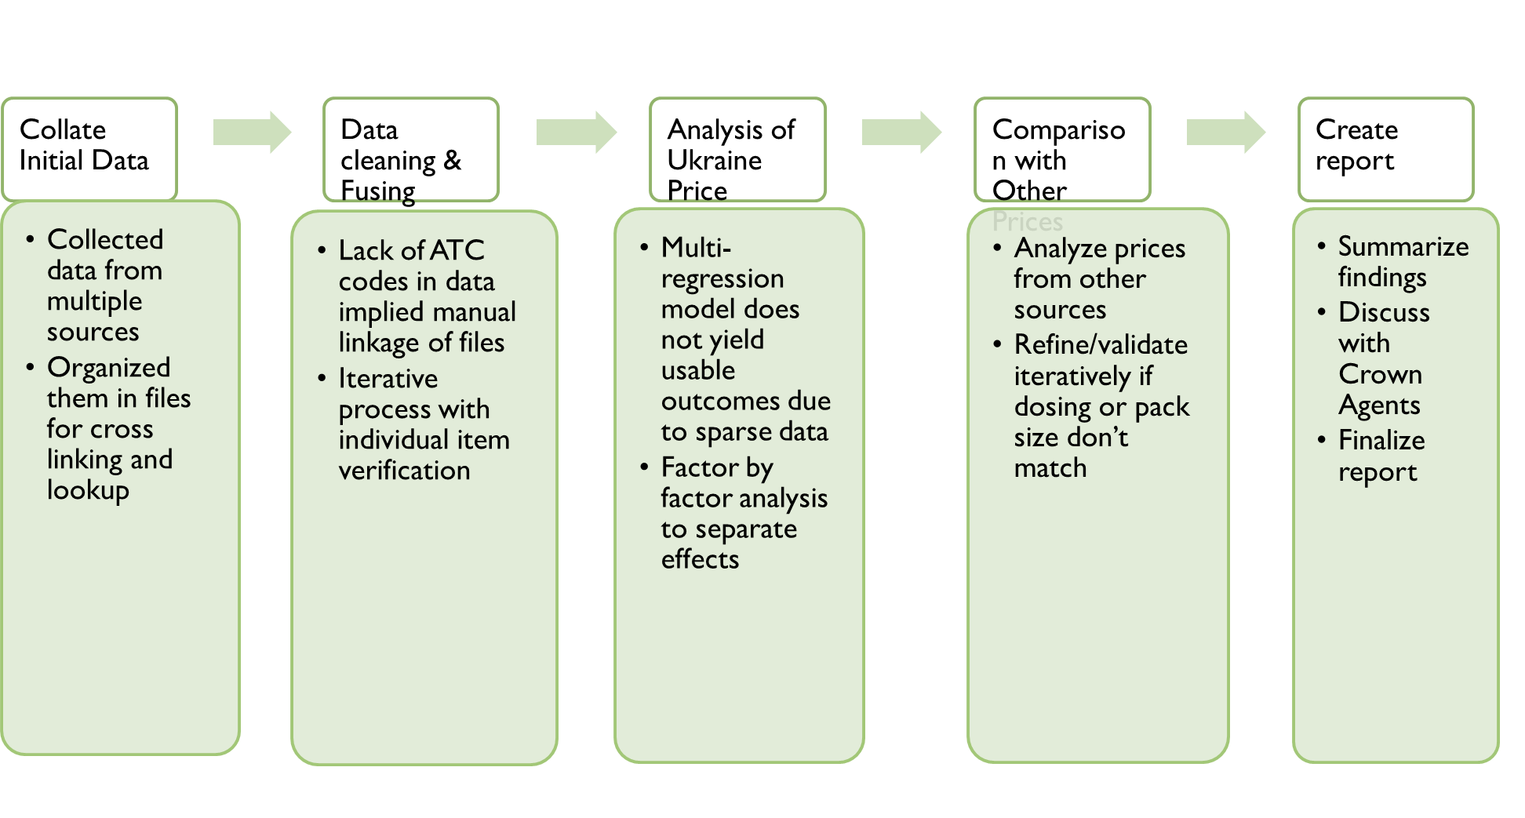

Figure 1: Study approach

Ideally, a multi-variate regression model would be used to explain the effect of different factors such as market changes, currency fluctuations, volume changes, input cost changes, and random effects on the change in prices from 2014 to 2015. The residual differences would then be attributed to procurement efficiencies and/or inefficiencies.
Many different specifications and data transforms were attempted; however, there were a large number of observations where there was sparse data on input cost changes, volume changes, or other market changes. As a result, none of these yielded reasonable outputs. Therefore, a factor-by-factor analysis was the only feasible approach to analysis.

Ideally, prices should be compared between products that are identical in terms of active ingredient, manufacturer, dosage form, strength, and pack size. In practice, different manufacturers in different countries sell their products in varying dosage forms, strengths, and pack-sizes. We applied a strict criterion for matching on ingredient, dosage form, strength, and pack size. However, by applying such strict matching criteria, some products were left out of the comparison and the number of comparators for each was therefore lower. Some would argue that a better approach is the use of standardized measures, such as defined daily doses (DDDs). However, the nonlinear variation in prices by strength and pack sizes led us to err on the side of sparser but strictly valid price comparisons. In a few instances where a product on Ukraine’s list had no other comparator and the concentration of an injectable product was measured by standard units, and where prices were available per unit, reasonable approximations were made. This was done for less than 5% of the total number of products analyzed.

All prices were converted to a common currency (U.S. dollars) for generating an accurate comparison. Some would argue that PPP rates should be used instead of exchange rates. However, as this is not an economic study, the focus is on the operational efficiency of procurement.

Manufacturers were separated into the following three categories based on the best available information on quality:
- Manufacturers with Stringent Regulatory Authority (SRA) approval for a given product
- Manufacturers without SRA approval for that product but with either SRA approval for another product or records of WHO GMP inspection reports
- All other manufacturers

Limitations of this study

Prices across countries depend on a variety of factors and need to be understood in their respective context. Our analysis does not capture the full complexity of price regulation, product selection, or procurement approaches used by each country, nor does it capture the effects from differential pricing tied to GDP that is carried out by some manufacturers.

Price comparisons made across countries include currency conversions that are applied based on the average exchange rate during the year of comparison. In reality, the exact impact of current volatility may differ because of the timing of when the suppliers and/or distributors obtained stock, pricing agreements with manufacturers in local currency, and currency risk hedging by some manufacturers. Some additional limitations are presented within the results section of this report.

Proxies are used to approximate changes in market conditions because exact changes in input costs, supply competition dynamics were not available systematically. Shortages and local market competitive market dynamics may render these proxies less useful for exact comparisons of specific drugs. However, as an aggregate they are still useful. Quality of manufacturers was measured using a 3 category scale. Attempts were made to obtain data on SRA approval, c-GMP status for each manufacturer to categorize them. However, in some cases information used may be slightly outdated.
RESULTS

Price reduction in 2015 as compared to 2014

A pairwise comparison was made of the change in the price of each drug from 2014 to 2015. A total of 6.5% was added to the manufacturer-negotiated price in 2015 to account for procurement fees for Crown Agents and clearance charges. The net price to the Ministry of Health of Ukraine decreased by an average of 37.9%. The median decrease was 44.5%. Approximately 84% of the items had a net lower price in 2015 as compared to 2014.

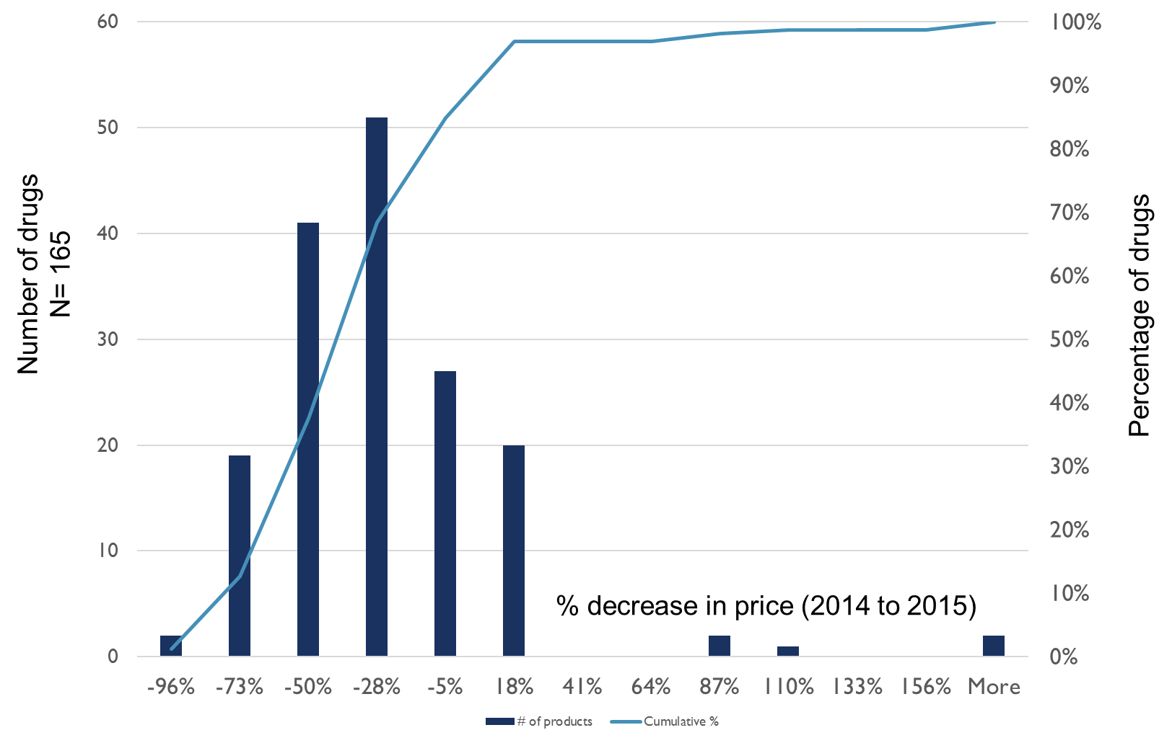

Figure 2: % price reduction in 2015 as compared to 2014

A “raw” decrease in prices, however, does not imply better procurement efficiency. Many confounding factors could lead to a price decrease, such as:
- Decrease in market price due to lower cost inputs
- Decrease in price due to higher volumes procured
- Decrease in price due to competition dynamics in the market (more suppliers)
- Decrease in price due to purchasing from lower cost suppliers
- Decrease in price due to favorable exchange rates
- Decrease in price due to procurement transparency and efficiency

Our identification strategy is best captured by the equation below:

Change in Price (2014-2015) = A (Change in Volume) + B (Change in Input Prices) + C (Change in Supplier Quality) + D (Change in Market Competition) + + E (Change in Currency) +” Randomness” + Residual

Residual = Effect that can be attributed to Procurement Efficiency

As described earlier, the multi-variate model to simultaneously estimate the impact of each factor did not yield results, so we compared each factor separately.

Change in Input Prices
There is lack of systematic data on input prices. Obtaining API price trends from India and China import/export data is more feasible for small molecules but challenging for biologics and complex drugs, which comprise a large portion of the drugs analyzed. We only captured input price changes for those products where price differences were larger than 50%. We used India import/export data from Zauba for that purpose. For an oral solid product where we can establish a clear single API, we used changes in the price of that API. Otherwise, we used export finished product price under the assumption that for products where there are multiple Indian generic producers, they are working on fixed margins and changes in their prices reflect input price changes.

Change in Market Competition
Changes in local and global market competition can have a significant impact on price. Some products may have shifted from being single-sourced to multi-sourced and their prices would decrease significantly due to such market dynamics. It is difficult to precisely track the number of active manufacturers for a product at a given time. “Active status” at a regulatory agency is the only publicly available dataset, but it does not confirm that a manufacturer is manufacturing and selling in the market that year.

As a result, we had to identify a proxy for changes in market conditions (input prices, competition dynamics). Data in prices from 2014 to 2015 for a large volume, sophisticated buyer would be reflective of directional changes of market conditions on price. To make this comparison, we use U.S. Center for Medicare and Medicaid Average Manufacturer Price data from 2014 and 2015. The challenge with using these data as a proxy is that prices in the U.S. have increased for certain injectable products due to local supplier shortages that have resulted from FDA quality issues. However, there were very few other sources for longitudinal price data.

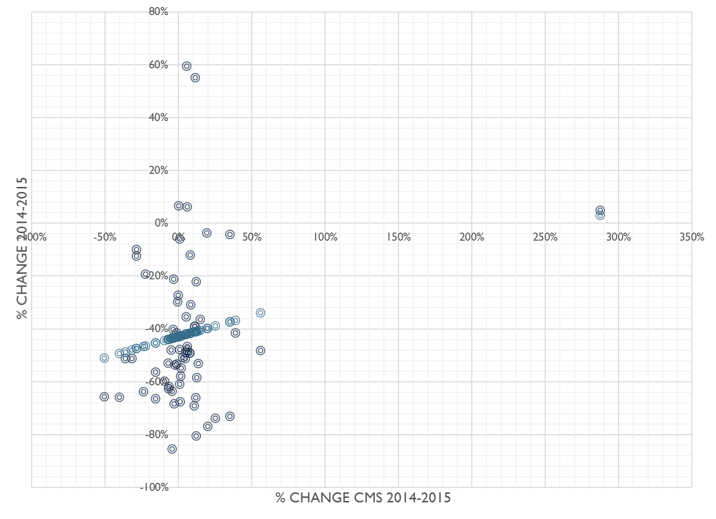
Figure 3 : Change in CMS prices as a proxy for changes in market conditions

Table 2:
 | Coefficients | Standard Error | P-value
Intercept (Change in Ukraine Manufacturer price) | -0.42779 | 0.036423 | 3.42E-17
% change CMS 2014-2015 | 0.159518 | 0.089345 | 0.079249

Figure 3 and Table 2 show that while some of the changes in prices obtained by Ukraine are explained by changes in overall market conditions, that effect is only a small portion of the overall price decreases/changes observed.

We conducted additional analyses to explore the impact of input cost changes on prices of select products whose prices in 2015 had increased as compared to 2014. Input costs changes for the three products listed in Table 3 do not explain price changes in Ukraine between 2014 and 2015. In fact, in some instances, the prices for these products increased when input costs or low cost manufacturer prices decreased.

Table 3: Input cost changes of selected products
Description | % change Ukraine price 2014-2015 | API Cost change or Low Cost Manufacturer Price Change
Anti-Thymocyte Globulin (Equine) | 77.3% | -7.3%
Rituximab | 6.2% | -6.8%
Tretinoin | 161.8% | 12.3%

How much of the 2014 to 2015 price decrease can be explained by increased volumes?

Higher volume is often associated with lower prices. It is therefore critical to examine whether the decrease in prices observed resulted from Ukraine procuring higher volumes.

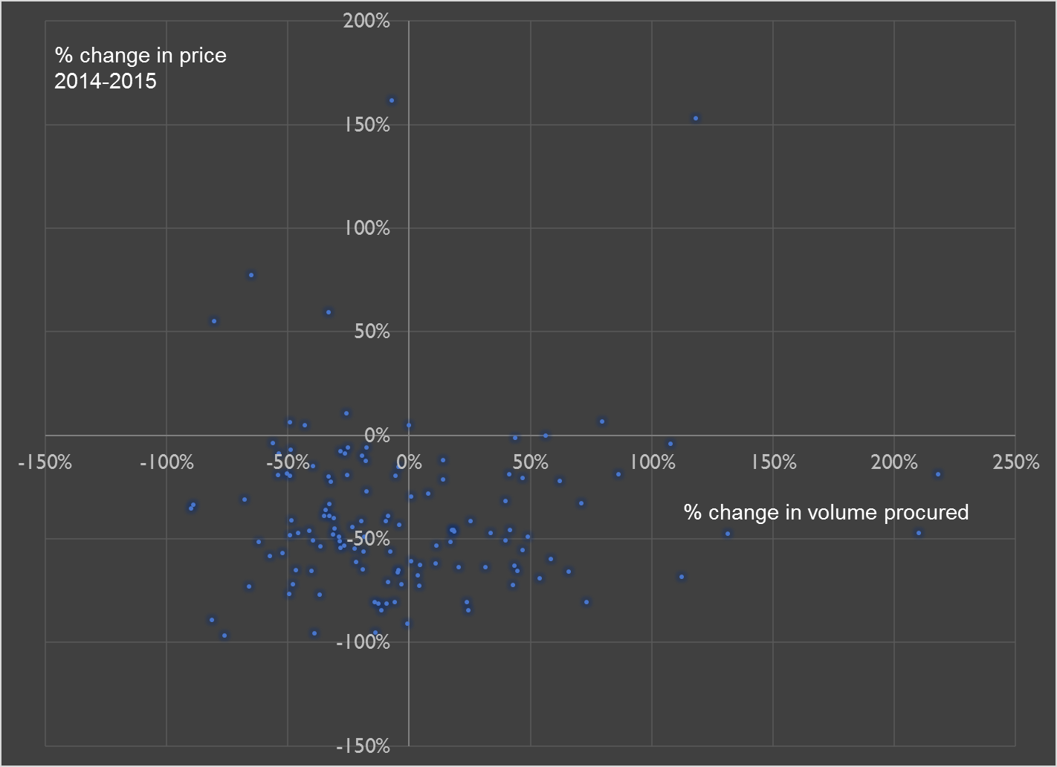

Figure 4: Change in Price vs. Change in Volume Procured

Figure 4 shows that there is no observed relationship (R2= 0.0067) between the change in volume procured and the change in price. In fact, price decreased irrespective of changes in volume. In other words, for a number of products, the total volume procured and the price both decreased from 2014 to 2015.

Could 2015 prices be lower because Ukraine started procuring from lower-quality manufacturers?

Information about manufacturers for 2014 procurement was not available to carry out an analysis of how it had changed over time. However, in 2015 a vast majority of products were procured from manufacturers with SRA approval.

Table 4: Manufacturing Quality in 2015 Procurement

Manufacturer Quality | % of 2015 procurement
SRA approved | 70%
Non SRA approved but GMP | 14%
Other | 16%

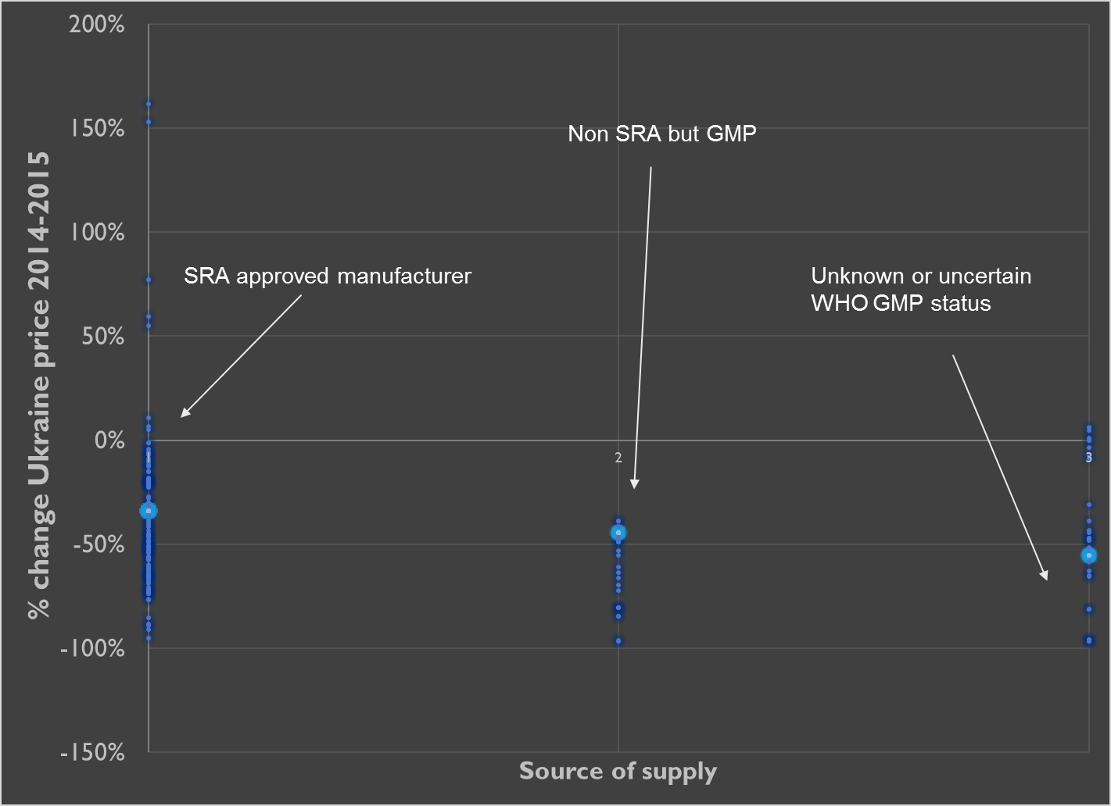

Figure 4: Change in Price vs. Manufacturer Quality Status

There is no evidence to suggest that prices have decreased due to sourcing from manufacturers with lower-quality standards. The few instances where prices have increased in 2015 are almost entirely from manufacturers that are SRA-approved. One exception is Rituximab whose prices have increased slightly and whose manufacturer is “Category 3,” i.e. non-SRA-approved and uncertain GMP status.

Impact of current volatility
The average exchange rates from UAH to USD decreased by 49.8%, implying that all USD-denominated drugs would be approximately 50% more expensive. This works in the opposite direction of the average price change, i.e. price decrease.

However, the exact impact of current volatility could be much less because of distributor inventory, pricing agreements with manufacturers in local currency and currency risk hedging by some manufacturers. Nevertheless, the impact of currency changes is working in the opposite direction as the price change as long as we assume that a majority of the drugs are purchased in USD-denominated purchase orders.

Comparison with prices paid by other procurers
Table 5 compares the net prices (inclusive of Crown Agent fees) paid by Ukraine in 2015 to prices paid by other large procurers.

 | IDPI median price | IDPI lowest price | Tamil  Nadu | Moldova | Brazil | South  Africa | CMS 2015 | CMS 2014 | Saudi 2014
Ukraine Price Higher | 60.0% | 77.9% | 89.4% | 26.5% | 35.0% | 53.8% | 28.1% | 29.7% | 12.7%
Ukraine Price Lower | 40.0% | 22.1% | 10.6% | 73.5% | 65.0% | 46.2% | 71.9% | 70.3% | 87.3%

It is evident that the price paid in Ukraine is lower than its comparators, including Moldova, Brazil, and Saudi Arabia for more than 70% of the drugs procured. Tamil Nadu Medical Supplies Corporation procures most of its drugs from local suppliers in India (a combination of Category 2 and 3, as per the quality classification in this study). Therefore, the prices in Tamil Nadu are lower than Ukraine in almost 90% of the cases.

However, as noted earlier in this report, prices obtained by countries depend on competition, intellectual property, price regulation, quality, and other factors. As such, comparisons should be viewed with caution.

CONCLUSION

The procurement of oncology drugs in Ukraine has achieved significant price reductions in 2015. The net price to the Ministry of Health of Ukraine decreased by an average of 37.9% and approximately 84% of the 168 items procured had a lower net price in 2015 as compared to 2014. A large portion of these reductions is due to greater procurement efficiency and transparency. Other factors, such as changes in volume, market conditions, and supplier quality have contributed only marginally to these price reductions. Prices obtained by Ukraine were better or comparable to most global procurers of high-quality oncology medicines. Additionally, these price reductions were achieved without compromising the quality of manufacturers.

The few instances where the prices in 2015 were higher than those in 2014 can be attributed to the limited number of suppliers registered in Ukraine to supply that product. Widely disseminating information about the size of the Ukraine market so that more suppliers can bid on future tenders may help to further improve the procurement spend. That would also enable companies with significant oncology portfolios to create distributor relationships in Ukraine.

Future Outlook
The combination of the increasing prevalence of most cancers, earlier treatment initiation, and better diagnoses will contribute to an expansion in volumes in the oncology portfolio over the next five years. Public payers will continue to closely scrutinize spending on oncology medicines. Issues of access and value will remain the focus of global discussion and debate.

A number of new medicines currently in clinical development or under regulatory review will be added to the oncology portfolio. Bio-similars will expand from epoetins and filgrastims to many of the Monclonal Antibodies (MAbs). The supply landscape for these new bio-similars will include both innovative pharmaceutical companies such as Pfizer, Merck, Sandoz and generic companies such as Mylan, Teva, BioE. In addition, more conventional injectable chemotherapy and other adjunctive drugs will be at a higher risk of supplier exit (as has already been observed for some products). In such an environment, it is crucial to have a procurement team with a deep understanding of the complex market landscape and the ability to obtain the best value for money for a payer and a purchaser.

References

- Anderson F. Methodological aspects of international drug price comparisons. Pharmacoeconomics. 1993;4(4):247–56
- Danzon PM, Kim JD. International price comparisons for pharmaceuticals. Measurement and policy issues. Pharmacoeconomics. 1998; 14(suppl. 1):115S–28S
- Danzon PM, Furukawa MF. Prices and availability of biopharmaceuticals: an international comparison. Health Affairs 2006;25(7):1353–62

Appendix A: Products analyzed

Item # | Description | Unit of Measure | Dosage | Adult/Child
1 | Amphotericin B – lipid complex | ampul, vial, syringe | 50 mg | Child
274 | Amphotericin B – lipid complex | ampul, vial, syringe | 50 mg | Adult
2 | Anti-Thymocyte Globulin (Equine) | ampul, vial, syringe | 250 mg | Child
3 | Anti-thymocyte Globulin (Rabbit) | ampul, vial, syringe | 25 mg | Child
4 | Asparaginase | ampul, vial, syringe | 10 000 IU | Child
5 | Asparaginase | ampul, vial, syringe | 5 000 IU | Child
275 | Asparaginase | ampul, vial, syringe | 10 000 IU | Adult
6 | Basiliximab | ampul, vial, syringe | 20 mg | Child
276 | Bendamustine | ampul, vial, syringe | 25 mg | Adult
277 | Bendamustine | ampul, vial, syringe | 100 mg | Adult
232 | Bevacizumab | ampul, vial, syringe | 100 mg | Adult
233 | Bevacizumab | ampul, vial, syringe | 400 mg | Adult
234 | Bicalutamide | tablet, capsule, pill | 50 mg | Adult
235 | Bicalutamide | tablet, capsule, pill | 150 mg | Adult
236 | Bleomycin | ampul, vial, syringe | 15 mg | Adult
280 | Bleomycin | ampul, vial, syringe | 15 mg | Adult
278 | Bortezomib | ampul, vial, syringe | 1 mg | Adult
279 | Bortezomib | ampul, vial, syringe | 3,5 mg | Adult
81 | Busulfan | tablet, capsule, pill | 2 mg | Child
26 | Calcium folinate | ampul, vial, syringe | 30 mg | Child
253 | Calcium folinate | ampul, vial, syringe | 30 mg | Adult
291 | Calcium folinate | ampul, vial, syringe | 30 mg | Adult
254 | Capecitabine | tablet, capsule, pill | 150 mg | Adult
255 | Capecitabine | tablet, capsule, pill | 500 mg | Adult
27 | Carboplatin | ampul, vial, syringe | 50 mg | Child
28 | Caspofungin | ampul, vial, syringe | 50 mg | Child
72 | Cefepime | ampul, vial, syringe | 1000 mg | Child
63 | Cisplatin | ampul, vial, syringe | 50 mg | Child
272 | Cisplatin | ampul, vial, syringe | 50 mg | Adult
273 | Cisplatin | ampul, vial, syringe | 100 mg | Adult
29 | Colistimethate sodium | ampul, vial, syringe | 2 000 000 IU | Child
61 | Cyclophosphamide | ampul, vial, syringe | 1 000 mg | Child
62 | Cyclophosphamide | tablet, capsule, pill | 50 mg. | Child
270 | Cyclophosphamide | ampul, vial, syringe | 200 mg | Adult
271 | Cyclophosphamide | ampul, vial, syringe | 500 mg | Adult
307 | Cyclophosphamide | ampul, vial, syringe | 1 000 mg | Adult
308 | Cyclophosphamide | ampul, vial, syringe | 500 mg | Adult
58 | Cyclosporine | tablet, capsule, pill | 100 mg | Child
59 | Cyclosporine | tablet, capsule, pill | 25,0 mg | Child
60 | Cyclosporine | vial, oral solution | 5000 mg | Child
84 | Cyclosporine | tablet, capsule, pill | 50 mg | Child
64 | Cytarabine | ampul, vial, syringe | 1 000 mg | Child
65 | Cytarabine | ampul, vial, syringe | 100 mg | Child
309 | Cytarabine | ampul, vial, syringe | 1 000 mg | Adult
310 | Cytarabine | ampul, vial, syringe | 100 mg | Adult
242 | Dacarbazine | ampul, vial, syringe | 200 mg | Adult
285 | Dacarbazine | ampul, vial, syringe | 200 mg | Adult
11 | Daptomycin | ampul, vial, syringe | 350 mg | Child
243 | Disodium folinate | ampul, vial, syringe | 437,2 mg | Adult
246 | Docetaxel | ampul, vial, syringe | 80 mg | Adult
247 | Docetaxel | ampul, vial, syringe | 140 mg | Adult
12 | Doxorubicin | ampul, vial, syringe | 10 mg | Child
13 | Doxorubicin | ampul, vial, syringe | 50 mg | Child
244 | Doxorubicin | ampul, vial, syringe | 10 mg | Adult
245 | Doxorubicin | ampul, vial, syringe | 50 mg | Adult
286 | Doxorubicin | ampul, vial, syringe | 50 mg | Adult
78 | Epіrubіcin | ampul, vial, syringe | 50 mg | Child
16 | Ertapenem | ampul, vial, syringe | 1000 mg | Child
287 | Erythropoietin ( Epoetin alfa) | ampul, vial, syringe | 10 000 МО | Adult
14 | Erythropoietin (Epoetin Alfa) | ampul, vial, syringe | 40 000 IU | Child
15 | Erythropoietin (Epoetin Beta) | ampul, vial, syringe | 30 000 IU | Child
17 | Etoposide | ampul, vial, syringe | 200 mg | Child
249 | Etoposide | ampul, vial, syringe | 200 mg | Adult
288 | Etoposide | ampul, vial, syringe | 200 mg | Adult
248 | Exemestane | tablet, capsule, pill | 25 mg. | Adult
55 | Filgrastim | ampul, vial, syringe | 30 million IU | Child
268 | Filgrastim | ampul, vial, syringe | 48 million IU | Adult
305 | Filgrastim | ampul, vial, syringe | 48 million IU | Adult
56 | Fludarabine | ampul, vial, syringe | 50 mg | Child
306 | Fludarabine | ampul, vial, syringe | 50 mg | Adult
269 | Fluorouracil | ampul, vial, syringe | 500 mg | Adult
57 | Fosfomycin | ampul, vial, syringe | 3 g | Child
10 | Ganciclovir | ampul, vial, syringe | 500 mg | Child
239 | Gemcitabine | ampul, vial, syringe | 200 mg | Adult
240 | Gemcitabine | ampul, vial, syringe | 1000 mg | Adult
83 | Gemcitabіne | ampul, vial, syringe | 1000 mg | Child
241 | Goserelin | ampul, vial, syringe | 10,8 mg | Adult
23 | Human normal immunoglobulin for intravenous administration 10% | ampul, vial, syringe | 50 ml | Child
67 | Hydrocortisone | ampul, vial, syringe | 100 mg | Child
284 | Hydroxycarbamide | tablet, capsule, pill | 500 mg | Adult
18 | Idarubicin | ampul, vial, syringe | 5 mg | Child
289 | Idarubicin | ampul, vial, syringe | 5 mg | Adult
25 | Ifosfamide | solution for infusion 10% ampul, vial, syringe | 1000 mg | Child
21 | Imatinib | tablet, capsule, pill | 100 mg | Child
22 | Imatinib | tablet, capsule, pill | 400 mg | Child
250 | Imatinib | tablet, capsule, pill | 100 mg | Adult
311 | Imatinib | tablet, capsule, pill | 100 mg | Adult
312 | Imatinib | tablet, capsule, pill | 400 mg | Adult
251a | Imatinib | tablet, capsule, pill | 400 mg | Adult
251b | Imatinib | tablet, capsule, pill | 400 mg | Adult
70 | Imipenem/Cilastatin | ampul, vial, syringe | 500mg/500mg | Child
290 | Imipenem/Cilastatin | ampul, vial, syringe | 500mg/500mg | Adult
252 | Irinotecan | ampul, vial, syringe | 100 mg | Adult
19 | Isotretinoin | tablet, capsule, pill | 10 mg | Child
20 | Isotretinoin | tablet, capsule, pill | 20 mg | Child
24 | Itraconazole | ampul, vial, syringe | 150 ml (10 mg/ml) | Child
68 | Lamivudine | tablet, capsule, pill | 100 mg | Child
69 | Lamivudine | oral solution | 1200 mg | Child
30 | Lenograstim | ampul, vial, syringe | 33,6 million IU | Child
293 | Lenograstim | ampul, vial, syringe | 33,6 million IU | Adult
257 | Letrozole | tablet, capsule, pill | 2,5 mg | Adult
31 | Linezolid | solution for infusion | 300 ml (2 mg/ml) | Child
32 | Lomustine | tablet, capsule, pill | 40 mg | Child
294 | Lomustine | tablet, capsule, pill | 40 mg | Adult
79 | Melphalan | ampul, vial, syringe | 50 mg | Child
299 | Melphalan | tablet, capsule, pill | 2 mg | Adult
82 | Meropenem | ampul, vial, syringe | 500 mg | Child
33 | Mesna | ampul, vial, syringe | 400 mg | Child
295 | Mesna | ampul, vial, syringe | 400 mg | Adult
35 | Methotrexate | tablet, capsule, pill | 2,5 mg | Child
36 | Methotrexate | ampul, vial, syringe | 10 mg | Child
37 | Methotrexate | ampul, vial, syringe | 1000 mg | Child
38 | Methotrexate | ampul, vial, syringe | 5 000 mg | Child
258 | Methotrexate | ampul, vial, syringe | 50 mg | Adult
296 | Methotrexate | ampul, vial, syringe | 50 mg | Adult
297 | Methotrexate | ampul, vial, syringe | 1000 mg | Adult
34 | Methylprednisolone | ampul, vial, syringe | 500 mg | Child
39 | Micafungin | ampul, vial, syringe | 100 mg | Child
40 | Micafungin | ampul, vial, syringe | 50 mg | Child
259 | Mitoxantrone | ampul, vial, syringe | 20 mg | Adult
298 | Mitoxantrone | ampul, vial, syringe | 20 mg | Adult
41 | Nilotinib | tablet, capsule, pill | 200 mg | Child
313 | Nilotinib | tablet, capsule, pill | 200 mg | Adult
71 | Ondansetron | ampul, vial, syringe | 4 mg | Child
260 | Oxaliplatin | ampul, vial, syringe | 50 mg | Adult
261 | Oxaliplatin | ampul, vial, syringe | 100 mg | Adult
262 | Paclitaxel | ampul, vial, syringe | 100 mg | Adult
43 | Pegaspargase | ampul, vial, syringe | 3750 IU | Child
44 | Pegfilgrastim | ampul, vial, syringe | 6 mg/0,6 ml | Child
42 | Piperacillin/Tazobactam | ampul, vial, syringe | 4500 mg | Child
300 | Piperacillin/Tazobactam | ampul, vial, syringe | 4 500 mg | Adult
45 | Posaconazole | ampul, vial, syringe | 105 ml (40 mg/ml) | Child
263 | Radiopharmaceuticals (diagnostic, therapeutic) and contrast media | ampul, vial, syringe | 350 mg/ml or 370 mg/ml 50 ml | Adult
46 | Rituximab | ampul, vial, syringe | 100 mg | Child
47 | Rituximab | ampul, vial, syringe | 500 mg | Child
301 | Rituximab | ampul, vial, syringe | 100 mg | Adult
302 | Rituximab | ampul, vial, syringe | 500 mg | Adult
48 | Teicoplanin | ampul, vial, syringe | 400 mg | Child
49 | Temozolomide | tablet, capsule, pill | 20 mg | Child
50 | Temozolomide | tablet, capsule, pill | 100 mg | Child
51 | Temozolomide | ampul, vial, syringe | 100 mg | Child
303 | Thalidomide | tablet, capsule, pill | 100 mg | Adult
52 | Ticarcillin/Clavulanic acid | ampul, vial, syringe | 3,0 g/0,2 g | Child
53 | Topotecan | ampul, vial, syringe | 4 mg | Child
264 | Topotecan | ampul, vial, syringe | 4 mg | Adult
265 | Toremifene | tablet, capsule, pill | 60 mg | Adult
266 | Trastuzumab | ampul, vial, syringe | 150 mg | Adult
76 | Treosulfan | ampul, vial, syringe | 1 g | Child
77 | Treosulfan | ampul, vial, syringe | 5 g | Child
54 | Tretinoin | tablet, capsule, pill | 10 mg | Child
304 | Tretinoin | tablet, capsule, pill | 10 mg | Adult
267 | Triptorelin | ampul, vial, syringe | 11,25 mg | Adult
80 | Tіoguanіne | tablet, capsule, pill | 40 mg | Child
66 | Urokinase | ampul, vial, syringe | 10 000 IU | Child
73 | Ursodeoxycholic acid | tablet, capsule, pill | 250 mg | Child
281 | Vancomycin | ampul, vial, syringe | 500 mg | Adult
7 | Vincristine | ampul, vial, syringe | 1 mg | Child
237 | Vincristine | ampul, vial, syringe | 1 mg | Adult
282 | Vincristine | ampul, vial, syringe | 1 mg | Adult
238 | Vinorelbine | ampul, vial, syringe | 50 mg | Adult
74 | Vinorelbine | ampul, vial, syringe | 10 mg | Child
8 | Voriconazole | tablet, capsule, pill, | 200 mg | Child
9 | Voriconazole | ampul, vial, syringe | 200 mg | Child
283 | Voriconazole | tablet, capsule, pill | 200 mg | Adult
256 | Zoledronic acid | ampul, vial, syringe | 4 mg | Adult
292 | Zoledronic acid | ampul, vial, syringe | 4 mg | Adult
75 | Іrinotecan | ampul, vial, syringe | 40 mg | Child

Appendix B

Currency Conversions Used (based on average 2015 exchange rates)
1 EUR = 1.15 USD
1USD = 0.0509 MDL
1 USD = 0.0140 RUN
1 USD = 67.5 INR
1 USD = 23.955 UAH (Also for 2014, 1 USD = 12.0275 UAH)

Drug regulatory authorities of Austria, Belgium, Bulgaria, Cyprus, Czech Republic, Denmark, Estonia, Finland, France, Germany, Greece, Hungary, Ireland, Italy, Latvia, Lithuania, Luxembourg, Malta, Poland, Portugal, Romania, Slovak Republic, Slovenia, Spain, Sweden, The Netherlands, United Kingdom, United States and Japan
Average in 2014, 1 USD = 12.0275 UAH, Average in 2015, 1 USD = 23.955 UAH

